Self Help Guide
Changing your password
Once password recovery options have been set on your account, you will be able to change your password at any time without having to contact the IT Service Desk.
This option allows you to change a valid password. There is a separate method to reset your password if you have forgotten it or if it has expired.
- Go to https://mypassword.bucks.ac.uk and choose the option to change your password, you will then be taken to a Microsoft page.
Enter your Bucks email*, choosing one of the below formats:
For Students (including Partner College students): <StudentID>@bucks.ac.uk(e.g 23456789@bucks.ac.uk)

For Bucks Staff: <FirstName.LastName>@bucks.ac.uk (e.g. Joe.Bloggs@bucks.ac.uk)

For Partner College Staff: <FirstName.LastName>@partner.bucks.ac.uk (e.g. Joe.Bloggs@partner.bucks.ac.uk)

*Partner college staff don’t need a Bucks email to reset their password, the above UPN will be set up to allow access.

Please ensure you are logged out of any Microsoft linked account before commencing setup (Outlook, Hotmail, Live, college or other organisational account)

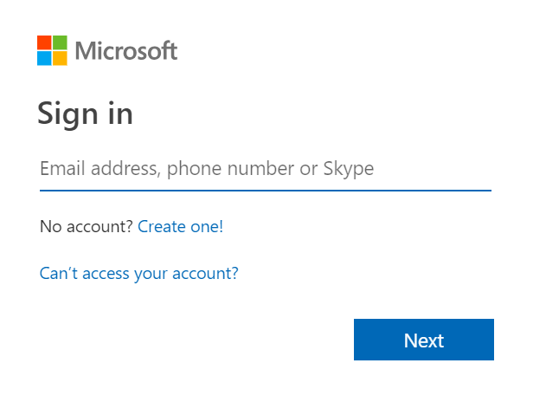
- Once you see the organisational sign in page, enter the appropriate above format of username and then the current password and click sign in.
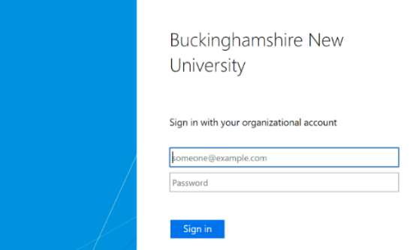

- Enter the current password and then set a new one. Click to submit to confirm.
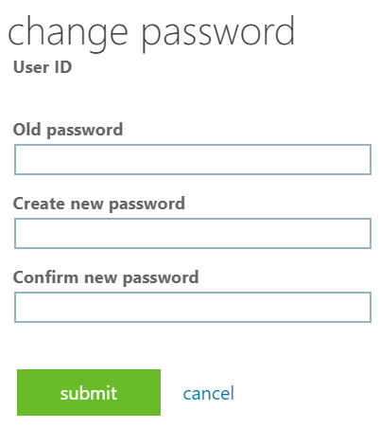

Your password has now been reset and is valid for 12 months. However, if at any time you believe your password has been compromised or made available to others, you must immediately change it and notify the IT Service Desk.

If you experience any issues resetting your password, please contact the IT Service Desk by emailing IT@bucks.ac.uk, calling 01494-605000 (Option 1) or visiting us on Level 2 in the Gateway Building.

